### March, 2018

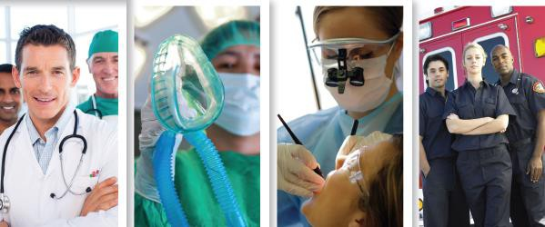

*Healthcare*

Workforce

ADDRESSING THE HEALTHCARE WORKFORCE NEEDS IN SOUTH DAKOTA THROUGH A PARTNERSHIP BETWEEN THE DEPARTMENTS OF EDUCATION, LABOR & REGULATION, HEALTH AND THE BOARD OF REGENTS

*Update*

**Inside This Issue**

1. **Healthcare Workforce Collaborative**
2. **SD Office of Rural Health Recruitment Programs**
3. **3RNet**
4. **Career Launch: Re-engaging Our Youth Workforce**
5. **2018 NHSC Loan Repayment Program (LRP)**
6. **Avera is Building the Future Workforce**
7. **Sanford Health Career Exploration & Opportunities**
8. **USD Chapter of the American Indian Science and Engineering Society (AISES)**
9. **Two Hospitals Tackle Workforce Challenges With Creative Solutions**
10. **HOSA Happenings: SD HOSA To Host 6th Annual State Leadership Conference**
11. **Small-Scale Mass Casualty Simulations Enhance IPE at Western Dakota Tech**
12. **Save the Date - 18th Annual Community Response to Child Abuse Conference**
13. **“Patients First” Approach Helps Retain Primary Care Providers**
14. **Office of Rural Health Administrator**
15. **Office of Rural Health Staff**
16. **DOH Social Media**
17. **More Information**

**Healthcare Workforce Collaborative**

Greetings from the South Dakota Office of Rural Health. This office along with our many partners continues to work at addressing South Dakota’s healthcare workforce needs. Read on to see what’s noteworthy over the past few months as well as what’s coming up in the near future! As always, we welcome your feedback regarding these and other workforce development issues.

## SD Office of Rural Health Recruitment Programs

*Contributed by Office of Rural Health*

### 2018 Rural Healthcare Facility Recruitment Assistance Program

The Rural Healthcare Facility Recruitment Assistance Program for 2018 is scheduled to open on May 1st with applicants being selected after July 1st. This program helps rural medical facilities in South Dakota recruit nurses and other health professionals by providing a $10,000 incentive payment to participating health professionals who complete a three-year service commitment in a community with 10,000 people or less. The program is filled on a first come, first served basis, so the Office of Rural Health suggests getting applications submitted in a timely manner. The application will be posted on the Office of Rural Health website page at <http://doh.sd.gov/providers/ruralhealth/recruitment/Facility.aspx>beginning on May 1st.

Applications must be submitted by the employing healthcare facility. Each eligible facility may have up to 3 participants each year. The following health professionals are eligible for this program: dietitians, medical laboratory scientists, nurses, occupational therapists, paramedics, pharmacists, physical therapists, radiologic technologists, respiratory therapists, speech therapists, and healthcare social workers.

For more information about the Rural Healthcare Facility Recruitment Assistance Program, email [Jill.Dean@state.sd.us](mailto:Jill.Dean@state.sd.us) or visit [http://ruralhealth.sd.gov.](http://ruralhealth.sd.gov/)

### Recruitment Assistance Program

The Recruitment Assistance Program provides qualifying physicians, dentists, physician assistants, nurse practitioners or nurse midwifes an incentive payment in return for three continuous years of practice in an eligible rural community. Providers must enter into a contract with the South Dakota Department of Health in order to qualify. The amount of the incentive payment for a qualifying physician or dentist is currently $208,754. The amount of the incentive payment for a qualifying physician assistant, nurse practitioner or nurse midwife is currently $56,880. To be eligible a community must:

* Have a population of 10,000 or less;
* Be assessed by the Department of Health to evaluate the community’s need for eligible providers and its ability to sustain and support additional providers, and be found eligible for participation; and
* Agree to pay a pro-rated portion of the total amount of the incentive payment.

o 0-2,500 population – 25%

o 2,501-4,999 population – 50%

o 5,000-10,000 population – 75%

For more information about the Recruitment Assistance Program, email [Jill.Dean@state.sd.us,](mailto:Jill.Dean@state.sd.us) or visit [http://ruralhealth.sd.gov.](http://ruralhealth.sd.gov/)



## 3RNet

*Contributed by Office of Rural Health*

Want a FREE and EASY way to reach a large healthcare applicant pool that stretches across the nation? The South Dakota Office of Rural Health administers the Rural Recruitment & Retention Network known as 3RNet. 3RNet is a nonprofit organization that helps connect healthcare providers across the nation with potential employers. Here’s how it works. Healthcare facilities advertise job openings at their facility on 3RNet and those job opportunities can be viewed by healthcare providers who register on 3RNet. At the same time, the website also allows registrations for healthcare providers who are seeking employment. All of the healthcare candidates that register on 3RNet and select South Dakota as a state of interest are sent to the Office of Rural Health. Approximately once a month, the Office of Rural health sends a list of those healthcare candidate registrations to healthcare facilities in South Dakota. This service is provided FREE to both healthcare facilities and healthcare providers. If your healthcare facility would like to post job opportunities, register at [www.3rnet.org](http://www.3rnet.org/) and click on the For Employers tab at the top of page. In addition, if your facility would like to receive the 3RNet healthcare candidate registrations who are interested in South Dakota, please email South Dakota’s organizational member, [Jill.Dean@state.sd.us.](mailto:Jill.Dean@state.sd.us)

## Career Launch: Re-engaging Our Youth Workforce

*Contributed by SD Department of Labor and Regulation*

Across the South Dakota, businesses are struggling to find qualified candidates to fill open positions. The healthcare field is no

exception. Due to stringent academic and extracurricular demands, student engagement in the workforce is also at an all-time low. Unfortunately, students with no real-world work experience can make unrealistic, and often costly, decisions about their futures.

In January’s State of the State Address, Governor Daugaard announced the Career Launch program that aims to address both issues.

1. Providing hands-on opportunities, such as job shadows, internships, and apprenticeships, to students while they are still in school will enable them to make sound and informed decisions about their futures.
2. Businesses who open their doors to students have a unique opportunity to showcase their industries and provide students with valuable insight and meaning surrounding their fields.

Through these work-based learning opportunities in the healthcare industry, students will gain invaluable knowledge and experience. Some students may even leave high school with some stackable credentials in the field, such as CPR/First Aid, Mandated Reporter, HIPAA, or even Certified Nursing Assistant certifications. They can carry these credentials with them into an immediate job opening and/or continued education after high school. What an incredible feeling of accomplishment for a young person!

The goal of Career Launch is to re-engage students in the workforce and invigorate our youth’s excitement regarding opportunities in their own communities and, in turn, meet the ever-rising demand for a skilled workforce here in our beautiful state of South Dakota.

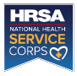LOAN REPAYMENT | SCHOLARSHIP

STUDENTS TO SERVICE

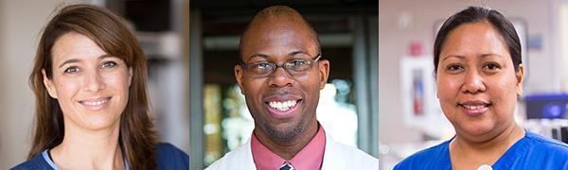

## 2018 NHSC Loan

**Repayment Program (LRP)**

**Accepting applications through April 23, 7:30 p.m. ET**

The National Health Service Corps (NHSC) seeks clinicians who demonstrate an interest in serving the nation’s medically underserved populations and remaining in Health Professional Shortage Areas beyond their service commitment. It is important to remember that the primary purpose of the NHSC LRP is to increase access to primary care services to communities in need.

The 2018 Application and Program Guidance (PDF - 510 KB) has the detailed information you need to apply, including eligibility requirements, site information, documentation, and service requirements. Please read carefully before you start your Loan Repayment Program application.

Approved sites are located across the U.S., in both urban and rural areas. Visit the Health Workforce Connector to see if your site is already approved.

Apply Here!

## Avera is Building the Future Workforce

### Career Planning Service for Students

*Contributed by Avera Health*



Avera’s career planning professionals help identify interests and connect students to resources to build a successful career path.

Mapping a path for a career in today’s health care environment requires careful planning. Career Services help students navigate the wide range of health care career opportunities at Avera with career planning resources, such as:

* Confidential career consultations in person or by phone, depending on the students location
* Help identifying career interests, strengths and passions
* Career exploration
* Career pathing
* Exploring job shadows, internships, volunteering and early employment opportunities To learn more go to <https://www.avera.org/careers/career-planning-service/>

#### Experiences for high school students

Avera Sacred Heart in Yankton is fortunate to work with an innovative school district. Our facility continues to provide experiences for high school students through the World of Work program, as well as offering internships which is a new concept for both YHS and ASHH. Both of these programs have been recognized at the state level as a model for other communities. The World of Work program was highlighted in the past at the national level. It is exciting to work with a high school senior through a job shadowing experience to have him/her apply as a licensed professional.

#### Scholarships

Avera believes in the value of education and offers a variety of scholarships to assist students and employees with their pursuit of knowledge.

* Five scholarships are given annually by [Avera St. Luke's Auxiliary](https://www.avera.org/locations/st-lukes/about-avera-st-lukes/) (Aberdeen) in the amount of $500 each. They are awarded to seniors in high school planning to enter an area of study in the health care field.
* The Kris Christensen Paramedic Fund provides scholarships for individuals accepted into the Avera McKennan School of Emergency Medical Services for the Paramedic Education program. For more information contact the [Avera McKennan Foundation](https://www.avera.org/support/mckennan-foundation/) at **605-322-8900**.
* Avera Health Leaders Scholarship for Students - [Avera Health Foundation](https://www.avera.org/support/avera-health-foundation/) provides the Avera Leaders Scholarship to nurture the next generation of leaders to share this vision with up to five $2,000 scholarships awarded each year.

Go to <https://www.avera.org/about/scholarships/>to learn about these and other scholarships.

## Sanford Health Career Exploration & Opportunities

*Contributed by Sanford Health*

#### No Idea of What You Want To Do in Healthcare? Join us for Sanford Youth Medical Explorers (YME)

Sanford Health is offering a summer program for high school students, new graduates and undergrad students who are interested in exploring health careers. The Sanford YME program allows students to explore healthcare roles through tours and conversations with healthcare providers in the departments of the Sanford Medical Center in Sioux Falls. Dates: June 11, 12, 13 (1:00pm to 3:30pm) See link for application and information for the summer and school year program: <https://www.sanfordhealth.org/about/academic-affairs/career-exploration>

Prepare for your future – apply now for the school year Sanford YME program with the same application on the link above. YME school year program also offers **HOSA (Health Occupations Student Association)** participation. HOSA is an international student organization recognized by the U.S. Department of Education and the Health Science Education (HSE) Division of ACTE, which provides students the opportunity to participate in HOSA activities, conferences and scholarships.

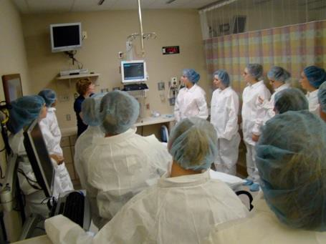

*Sanford YME touring the Sanford Post Anesthesia Care Unit.*

#### Educational Tours for Undergrads and High School Students

Bring a group of your classmates to explore healthcare careers at Sanford USD Medical Center in Sioux Falls, tours available for all students to interact with healthcare professionals as they visit various hospital and outpatient departments. For more information about these opportunities, please contact: [kelly.tollefson@sanfordhealth.org](mailto:kelly.tollefson@sanfordhealth.org)

#### Resume Builder for Students – Volunteering

Sanford Volunteers are in high demand and need students to volunteer throughout the Sanford campus. This first step into healthcare is valuable for student volunteers as they work alongside staff to serve our patients. Another perk for volunteers, Sanford USD Medical Center student volunteers are eligible for the Health Career Scholarship to benefit student volunteers enrolled in health career programs. Scholarship awards of up to five $2,000 scholarships and up to five $1,000 scholarships as provided by the Sanford USD Medical Center Volunteer Advisory Board. See additional information at: [http://www.sanfordhealth.org/careers/volunteer-opportunities/sioux-](http://www.sanfordhealth.org/careers/volunteer-opportunities/sioux-falls) [falls.](http://www.sanfordhealth.org/careers/volunteer-opportunities/sioux-falls)

#### Sanford Research

Sanford Research located at the Sanford Center in Sioux Falls, provides undergrads and high school students an insider’s view of research. Students are eligible to apply for shadowing and numerous hands on activities and research project internships, click on the link to view all available opportunities: <http://www.sanfordresearch.org/education/k12students/>

## USD Chapter of the American Indian Science and Engineering Society (AISES)

*Contributed by University of South Dakota*

The University of South Dakota’s chapter of the national American Indian Science and Engineering Society (AISES) has been recognized as the 2017 Chapter of the Year for Outreach and Community Service. AISES is a national non-profit organization focusing on substantially increasing the representation of American Indians, Native Hawaiians, Pacific Islanders, First Nations and other indigenous peoples of North America in science, technology, engineering and math (STEM) studies and careers.

Over the past year, the chapter has held a number of events for Native American high school students from South Dakota. The Chapter hosted several dinners for students visiting USD from Pine Ridge High School, Red Cloud Indian School and Vermillion High School. Early last fall chapter members traveled to White River Middle School where they talked with the students about substance abuse prevention and in December the chapter volunteered at the Welcome Table, a non- profit organization in Vermillion, SD that provides meals to needy community members.

The USD AISES Chapter is comprised of approximately 25 members and represents 14 different tribes from across the United States. An official awards ceremony will be held during the AISES Leadership Summit in Alpine, CA in late March. To learn more about the National AISES Organization, please log on to aises.org. For additional information about the USD Chapter, please contact chapter advisors, Kathy Van [kathy.vankley@usd.edu](mailto:kathy.vankley@usd.edu) or Chelsea Wesner [Chelsea.Wesner@usd.edu.](mailto:Chelsea.Wesner@usd.edu)



## Two Hospitals Tackle Workforce Challenges With Creative Solutions

*Contributed by South Dakota Association of Healthcare Organizations*

Recruiting and retaining employees is a challenge for many industries in South Dakota, but two SDAHO members took on the challenge head-first with collaborative efforts and creative solutions.

Avera St. Benedict Health Center in Parkston found that it wasn’t only difficult to recruit candidates to fill health care positions, but once a qualified candidate was found, the next barrier was finding housing. This led to a partnership between Avera St. Benedict, Avera Health and the Parkston Area Development Foundation to create affordable housing. Read about their creative housing solution in [MED Mag.](http://www.midwestmedicaledition.com/2018/02/23/167610/workforce-housing-is-mission-critical-for-rural-facility)

Roughly 90 miles away from Parkston, another creative workforce solution has been found. Madison Regional Health System has partnered with Dakota State University (DSU) to create the Workforce Development Alliance (WDA). WDA is a new initiative which allows businesses to underwrite a portion of a student’s education and provide internship opportunities during their college years. In return, the student commits to work for that business for a period of time. It’s a win-win for DSU and Madison Regional Health System. Read the [full story](http://dsu.edu/news/dsus-new-workforce-development-alliance-a-win-for-everybody) on DSU’s website.

## HOSA Happenings: SD HOSA To Host 6th Annual State Leadership Conference

*Contributed by AHEC Program Office*

Developing the healthcare workforce pipeline requires exposing kids to health careers, providing healthcare experiences and building relevance from school curriculum to careers in healthcare. South Dakota HOSA – Future Health Professionals continues to grow. This year, SD HOSA surpassed the 800 member mark!

Our 6th Annual SD HOSA State Leadership Conference will be held on April 5-6, 2018 Sanford Sports Complex in collaboration with Sanford Research, Avera McKennan Prairie Center, Southeast Technical Institute, All City Pet Care, and Midwest Periodontics.

At the conference SD HOSA members will compete as

individuals and/or teams, attend academic sessions, and tour healthcare facilities in the area.

Through the Competitive Events Program (CEP) of HOSA, members compete in events including, but not limited to *Medical Photography, Biomedical Debate, Physical Therapy, Nursing Assisting, Public Service Announcement, Nursing Assisting, Medical Math and Extemporaneous Poster* etc.

Through the CEP students create projects, practice procedures, and increase their knowledge-base regarding healthcare career opportunities. Students win awards and earn an opportunity to represent South Dakota at the HOSA International Leadership Conference in Dallas, TX.

Although most of the focus will be on the 55+ competitive events, the State Conference is also providing FOUR dynamic Education Symposia including:

1. ACL reconstruction
2. Imaginetics
3. Transplant Surgery
4. Biomedical Engineering

Also included during the two-day event is a Grand Award Session, 15+ academic breakout sessions, 6 tours, a college/workforce exhibit fair and a keynote/banquet.

Licensed health professionals that have volunteered their time to make this event special include physical therapists, dentists, researcher, nurses, and veterinarians. They are able and willing to provide service for over 600 HOSA members planning to attend the event.

If you would like more information about the SD HOSA State Leadership Conference or would like to attend, please email the South Dakota HOSA State Advisor Brock Rops at [Brock.Rops@usd.edu](mailto:Brock.Rops@usd.edu) or call him at 605.357.1576.



## Small-Scale Mass Casualty Simulations Enhance IPE at Western Dakota Tech

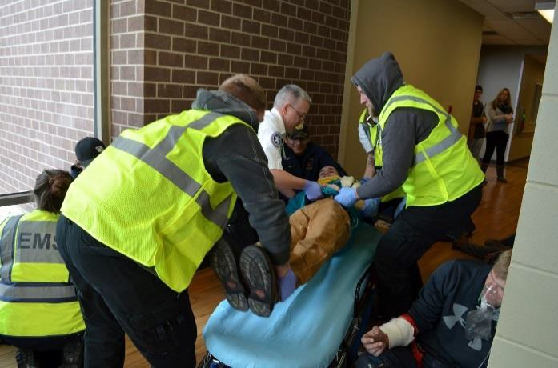

*Contributed by Western Dakota Tech*

While the terms “small scale” and “mass casualty” may seem to contradict one another, the Paramedic program and Simulation Center at Western Dakota Tech have teamed up to develop small-scale (six to ten patient) mass casualty simulations for second-semester Paramedic students.

Over the course of three days, students are dispatched as separate ambulance units with the first team on scene in charge of triage. The additional Paramedic students arrive later in the scenario to assist with treatment and transport. The number of patients is designed to focus the first responders on scene safety, triage, and needs assessment without overwhelming the students with massive amounts of carnage that may hinder the learning process.

In preparing future graduates for real-world careers, events such as these also provide pathways to enhance inter-professional education. During the three days of mass casualty training, patients were provided from across the WDT campus to include transportation technology, welding, criminal justice, and law enforcement. Scenarios included various injuries in a vehicle maintenance shop accident, an oxy-acetylene bottle explosion in a welding shop, a natural gas leak and explosion at a local jail, and a drug house shooting. These tailored scenarios allowed the participating classes to consider topics such as OSHA safety regulations and exposed them to interactions with EMS in the event of an emergency. Equally, Paramedic students were required to effectively communicate with patients as part of their assessment and treatment. Additionally, Paramedic students in route to the Simulation Center ER were required to give a radio report to the Practical Nursing program and then perform an effective handoff of each of their patients. The three days of training were not only a part of the planned schedule of the course, but also a great preparation event for the WDT Sim Rally, a large mass casualty event scheduled for late April 2018.

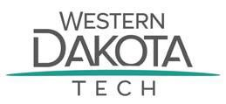

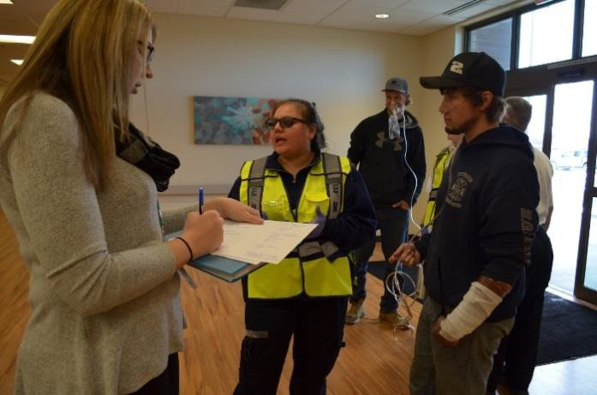

## Save the Date - 18th Annual Community Response to Child Abuse Conference

*Contributed by University of South Dakota*

The Center for the Prevention of Child Maltreatment (CPCM) is honored to collaborate with Child's Voice and the Unified Judicial System (UJS) Court Improvement Program (CIP) to host a conference for professionals and advocates regarding a community response to child abuse. The conference is scheduled for October 4 and 5, 2018, at the Sioux Falls Convention Center and features keynote speakers Jim Tanner and Olga Trujillo.

We have opted to keep the Child's Voice conference title: Annual Community Response to Child Abuse. The UJS CIP Children's Justice Conference will not be held separately. The topics normally addressed at the Children's Justice Conference will be combined into the Annual Community Response to Child Abuse Conference.

CPCM will join Child's Voice and UJS CIP in disseminating research and training based on their ten- year plan to end the child maltreatment.

Continue to watch CPCM's website ([www.sdcpcm.com](http://www.sdcpcm.com/)) for updates, announcements and registration information.



## “Patients First” Approach Helps Retain Primary Care Providers

*Contributed by South Dakota Association of Healthcare Organizations*

The Centers for Medicare and Medicaid Services (CMS) launched the “Patients over Paperwork” initiative in October 2017. The goal of the initiative is to reduce unnecessary paperwork, increase efficiencies and improve the patient experience. The initiative was the theme of the 2018 CMS Annual Quality Conference held in February 2018 and included more than 2,700 attendees.

The “Patients over Paperwork” initiative is one of the keys to assisting rural health care organizations with workforce shortages. It is estimated that primary care physicians spend 27 percent of their time on clinical activities and 49 percent on administrative activities, according to a Annals of Internal Medicine study from 2016. The ever-growing number of administrative tasks forced on physicians and their practices adds unnecessary costs to the U.S. health care system, individual physician practices and the patients themselves.

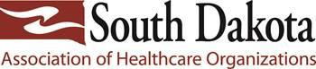Excessive administrative tasks also divert time and focus from the clinically important activities of physicians, providers and their staff. Physicians have grown frustrated with excessive paperwork that distracts them from direct patient care, who often have waited weeks, if not months, for the brief opportunity to see a physician. Unfortunately, the excessive administrative burden is keeping physicians from entering or remaining in primary care. The increase in administrative tasks also has been linked to greater stress and burnout among physicians who may subsequently leave the practice of medicine.

*Learn more about* [Patients Over Paperwork.](https://www.cms.gov/Outreach-and-Education/Outreach/Partnerships/Downloads/PoPDecember2017Newsletter.pdf)

## Office of Rural Health Administrator

*Contributed by Office of Rural Health*

Andy Klitzke is the new Administrator for the Office of Rural Health. He comes to Rural Health after 8 years with the Office of Public Health Preparedness & Response where he collaborated with hospitals, clinics and long-term care facilities to develop the capabilities of healthcare organizations and their communities to prepare for, respond to, and recover from disasters. He led public health and medical planning for the Sturgis Motorcycle Rally and served as the state planner for several community Point-of-Dispensing (POD) groups. Andy earned a Master’s Degree in Health Services Administration from the University of Michigan School Of Public Health in 2008.



**Office of Rural Health Staff**

# Rebecca Baird

**Jill Dean**

**Bob Hardwick Michelle Hoffman**

**Lance Iversen Andy Klitzke Marty Link Josie Petersen**

**Katie Reuman Julie Smithson DeAnn Sprenger**

## DOH Social Media

*Contributed by SD Office of Rural Health*

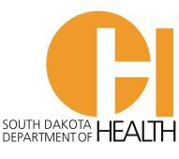What’s happening at the South Dakota Department of Health and the Office of Rural Health? Keep informed at these social media accounts.

DOH on Facebook – <https://www.facebook.com/SDHealthDepartment> DOH on Twitter – <https://twitter.com/SDDOH>

SD Health Careers on Twitter - <https://twitter.com/SDHealthCareers> HOTT on Facebook - <https://www.facebook.com/SDHealthCareers?ref=hl>

SIM-SD on Facebook - <https://www.facebook.com/Simulation-in-Motion-South-Dakota-131973850231573/timeline/>

## More Information?

Contact [Josie Petersen,](mailto:josie.petersen@state.sd.us) Department of Health

If you would like to be removed from this distribution list, please contact [Josie Petersen.](mailto:josie.petersen@state.sd.us)